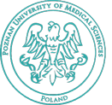
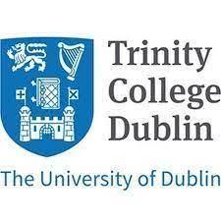
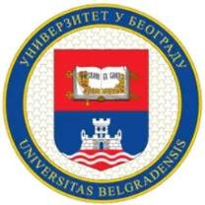

WORKSHOPS:

-The number of places is limited – participation will be granted on a first-come, first-served basis.
- Online registration will open in September.

1. Medical Simulation Center - Interprofessional Workshops for Specialists

Assoc. Prof. Patrycja Marciniak-Stępak, Poznan University of Medical Sciences, Poland
Assist. Prof. Łucja Zielińska-Tomczak, Poznan University of Medical Sciences, Poland

These workshops introduce educators to practical methods for implementing interprofessional education through simulation‑based learning. Participants will have the opportunity to observe how classes using this approach are conducted and exchange experiences with instructors who facilitate such scenarios on a daily basis. The workshops are intended not only as a space for sharing insights, but also as a demonstration of the possibilities offered by interprofessional education using simulated patients.

2. Widening perspectives at interprofessionalism in the One Health and Sustainable Development Goals era

Assoc. Prof. Janusz Janczukowicz, Medical University of Lodz, Poland

The aim of this workshop is to initiate the discussion on the role of students and faculty in responding to the contemporary, complex, global challenges, ranging from antimicrobial resistance to climate-driven health risks. Widening perspectives on interprofessionalism in the era of One Health and the Sustainable Development Goals (SDGs) requires moving beyond traditional, siloed collaboration toward genuinely integrated practice that connects human health, animal health, environmental systems, and societal well-being. This shift emphasizes not only joint education and cooperation among healthcare professions but also meaningful engagement with disciplines such as ecology, veterinary medicine, public policy, urban planning, and social sciences, recognizing that global challenges cannot be addressed within single domains. Interprofessionalism in this context becomes a dynamic, systems-oriented approach, aligning health workforce education and practice with the interconnected priorities of the SDGs.

3. Masters of Medical Skills. Interdisciplinary Education for Students
Tomasz Kłosiewicz PhD Poznan University of Medical Sciences, Poland

The training includes the implementation of two high-fidelity simulation scenarios focused on communication and interdisciplinary collaboration within teams composed of representatives of various medical and allied health professions (including nurses, paramedics, physicians, pharmacists, and other healthcare system professionals). The scenarios are conducted in pre-hospital and in-hospital settings, as well as in high-risk environments incorporating elements of tactical medicine.

The scope covers knowledge, skills, and competencies related to: collecting key clinical data and identifying priorities for action, including in resource-limited and potentially unsafe conditions; making decisions in emergency situations and clearly justifying them to the team; maintaining effective, concise communication under stress and in dynamically changing operational environments; practicing active listening and integrating perspectives from diverse professional groups, including the role of pharmacists in ensuring safe and effective pharmacotherapy; fostering interdisciplinary collaboration through task allocation, delegation, and mutual support; managing stress and maintaining team performance under time pressure and threat; applying fundamental principles of tactical medicine, such as prioritizing life-saving interventions (e.g., control of massive hemorrhage, airway management, and casualty evacuation); analyzing the consequences of decisions and adapting strategies flexibly to evolving conditions.

4. New Medicine Service – patient communication in interprofessional collaboration to support adherence

Assoc. Prof. Magdalena Waszyk-Nowaczyk, Poznan University of Medical Sciences, Poland
Assoc. Prof. Magdalena Jasińska-Stroschein, Medical University of Lodz, Poland
Olga Sierpniowska, MSc, Poznan University of Medical Sciences, Poland

This workshop focuses on the role of patient communication within the New Medicine Service as a key element of integrated care. articipants will explore how effective communication between pharmacists and patients, as well as collaboration with other healthcare professionals, contributes to adherence, as well as the safety and effectiveness of pharmacotherapy.. Particular emphasis will be placed on building therapeutic relationships, identifying drug-related problems, and supporting shared decision-making within an interprofessional care model. The workshop will have a practical format, including case studies and communication exercises.

